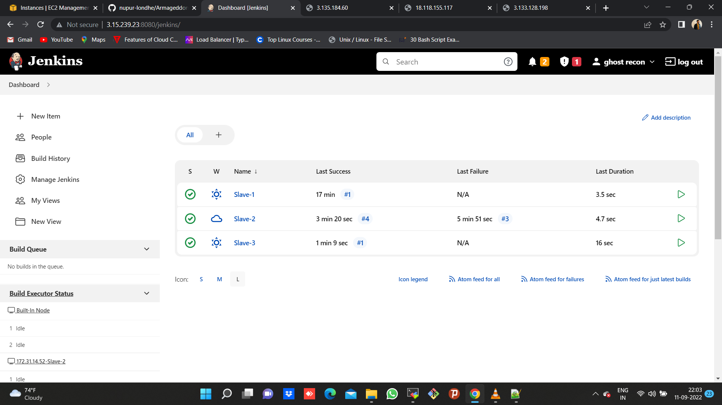

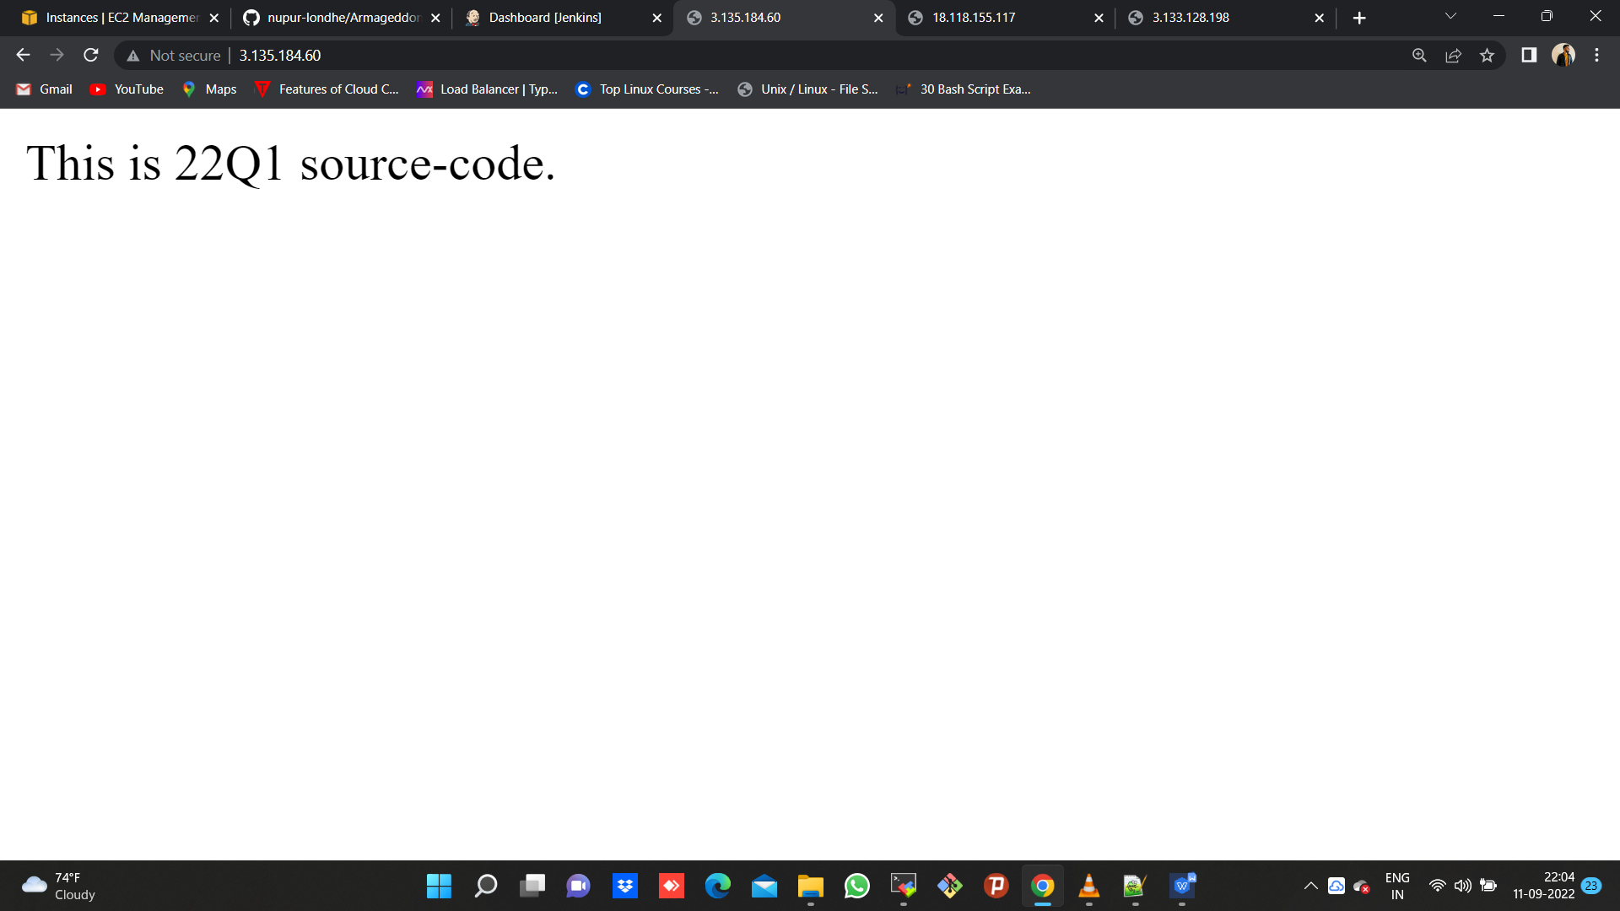

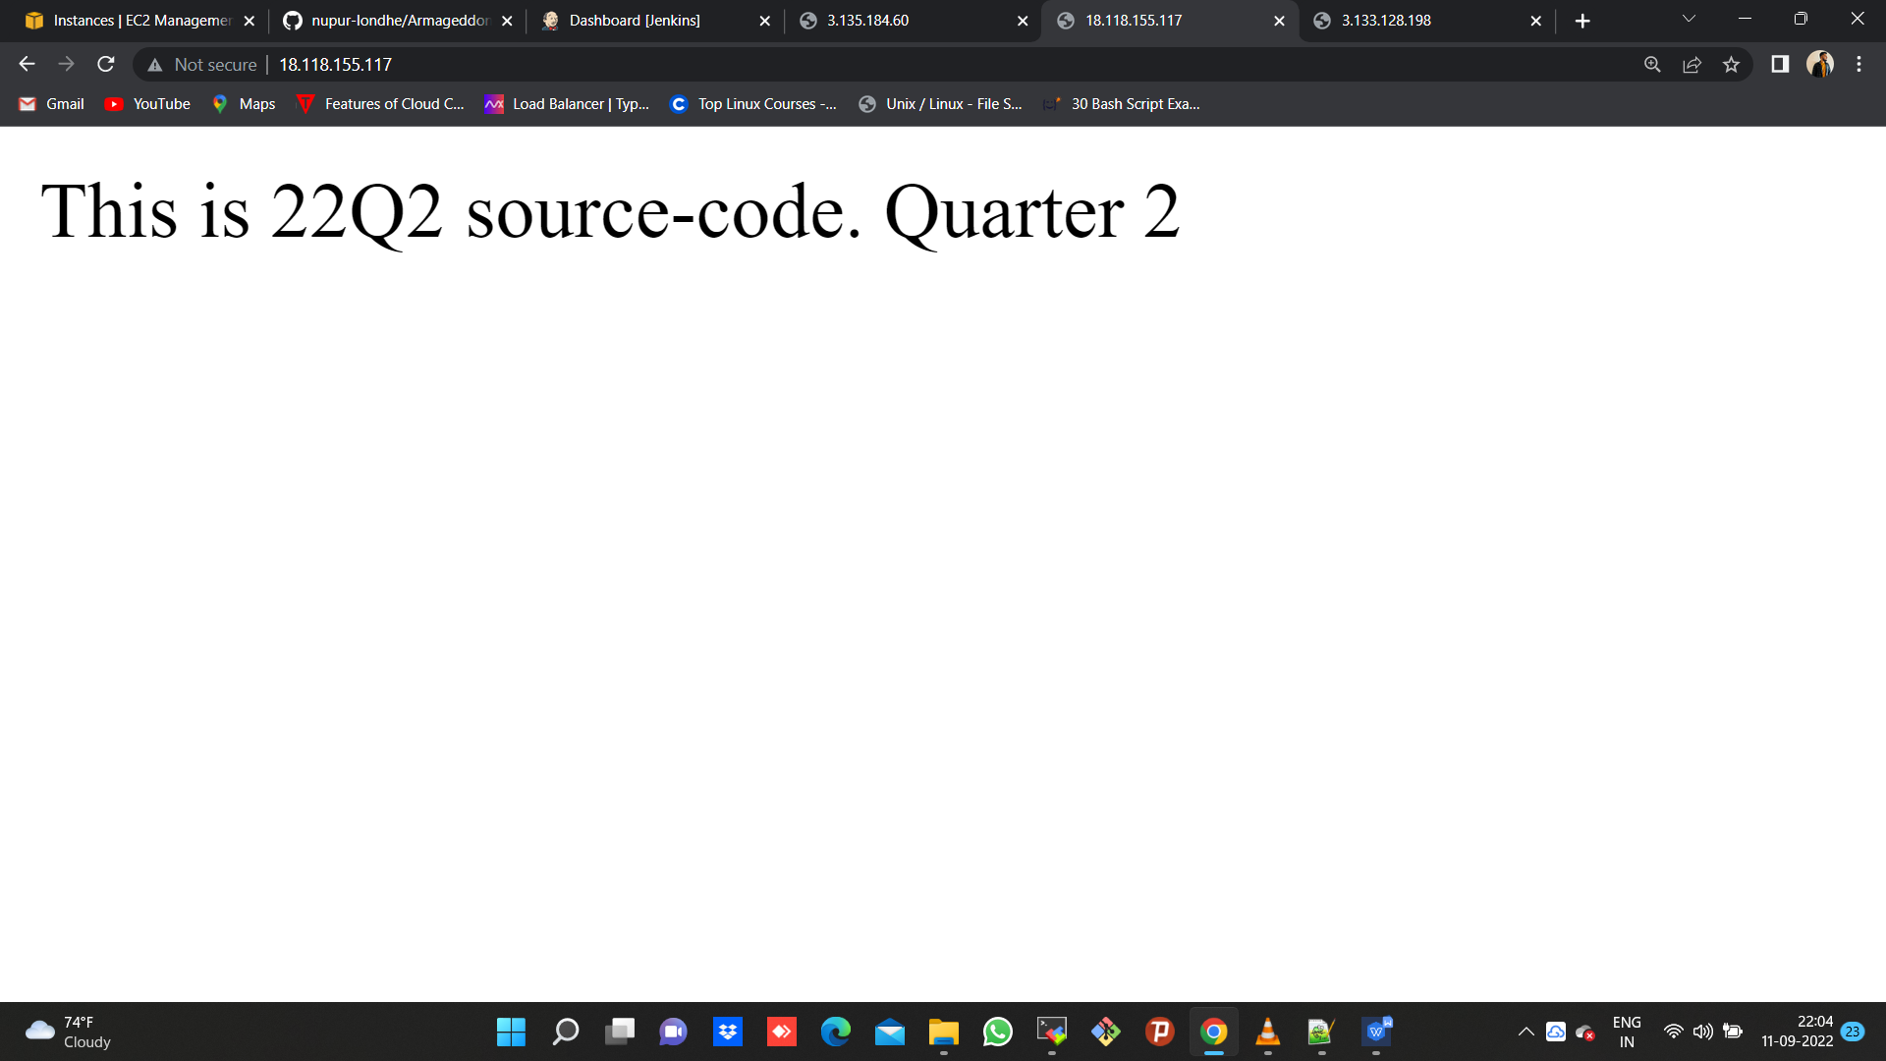

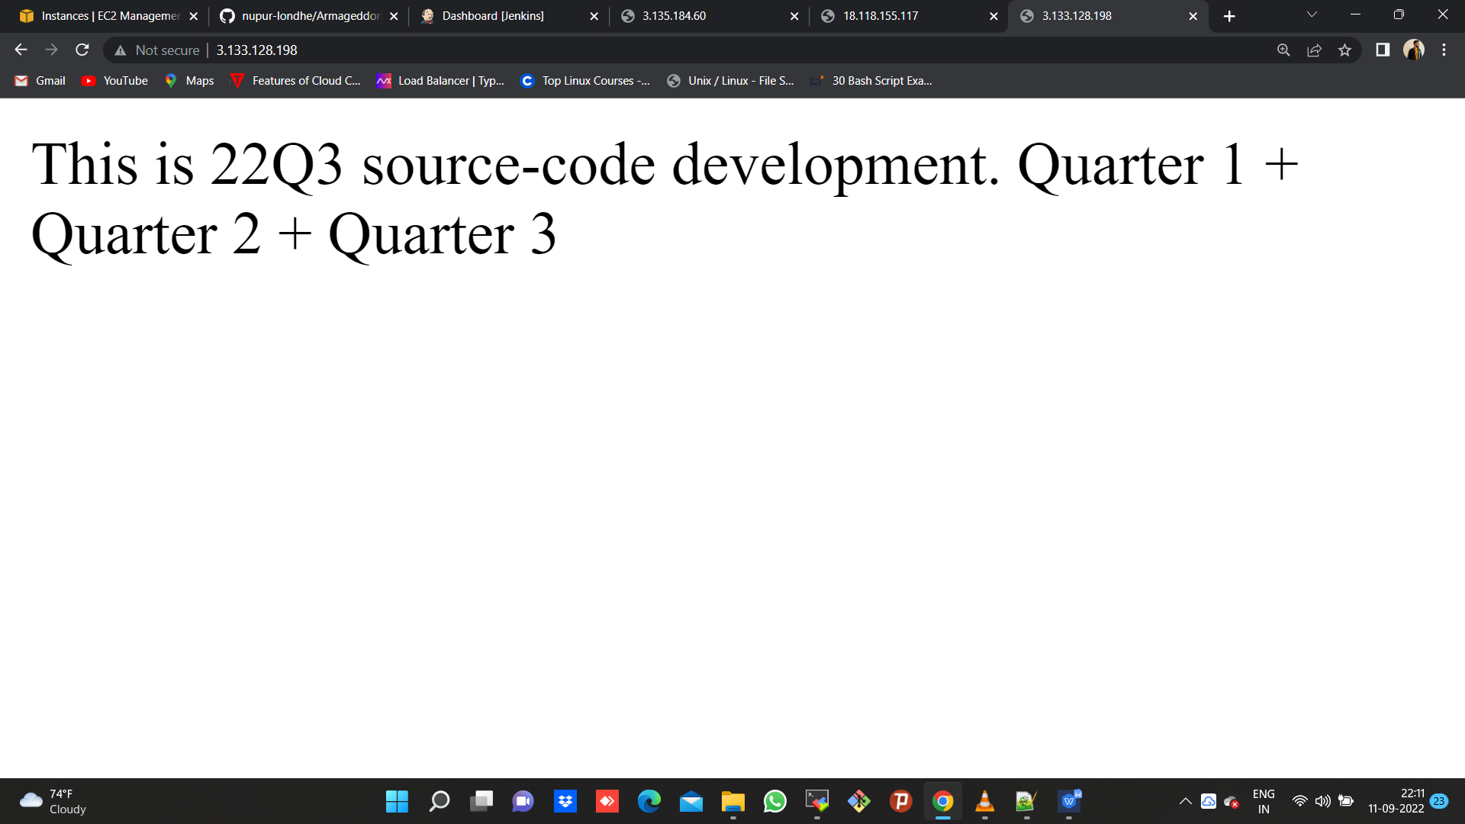

**Job/pipeline -1**

pipeline {

agent {

node {

label "172.31.7.153-Slave-1"

customWorkspace "/mnt/nupur"

}

}

stages {

stage ('clone your git repository containing index file') {

steps {

sh "git clone https://github.com/nupur-londhe/Armageddon.git -b master"

}

}

stage ('install httpd & host index file to webserver') {

steps {

sh "yum install httpd -y"

sh "service httpd start"

sh "chkconfig httpd on"

sh "cp -r /mnt/nupur/Armageddon/index.html /var/www/html"

sh "chmod -R 777 /var/www/html/index.html"

}

}

}

}

**Job/pipeline -2**

pipeline {

agent {

node {

label "172.31.14.52-Slave-2"

customWorkspace "/mnt/nupur"

}

}

stages {

stage ('clone your git repository containing index file') {

steps {

sh "yum install git -y"

sh "git clone https://github.com/nupur-londhe/Armageddon.git -b 22Q2"

}

}

stage ('install httpd & host index file to webserver') {

steps {

sh "yum install httpd -y"

sh "service httpd start"

sh "chkconfig httpd on"

sh "cp -r /mnt/nupur/Armageddon/index.html /var/www/html"

sh "chmod -R 777 /var/www/html/index.html"

}

}

}

}

**Job/pipeline -3**

pipeline {

agent {

node {

label "172.31.30.38-Slave-3"

customWorkspace "/mnt/nupur"

}

}

stages {

stage ('clone your git repository containing index file') {

steps {

sh "yum install git -y"

sh "git clone https://github.com/nupur-londhe/Armageddon.git -b 22Q3"

}

}

stage ('install httpd & host index file to webserver') {

steps {

sh "yum install httpd -y"

sh "service httpd start"

sh "chkconfig httpd on"

sh "cp -r /mnt/nupur/Armageddon/index.html /var/www/html"

sh "chmod -R 777 /var/www/html/index.html"

}

}

}

}